**Name: ________________________________**

**Roll no:- ___________**

**Index**

|  |  |  |  |
| --- | --- | --- | --- |
| **Sr.no** | **Experiment Name** | **Date** | **Sign** |
| **1.** | **Find the Minimum and Maximum value in a given array.** |  |  |
| **2.** | **Find the Smallest and Largest number using array.** |  |  |
| **3.** | **To checks the temperature** |  |  |
| **4.** | **Create array of 5 float element & Calculate their sum.** |  |  |
| **5.** | **Find out whether a given integer is present in an array or not.** |  |  |
| **6.** | **Calculate the Avarage marks from an array containg marks of all Students in java using for loop.** |  |  |
| **7.** | **Write a program to Reverse in array.** |  |  |

**Output**

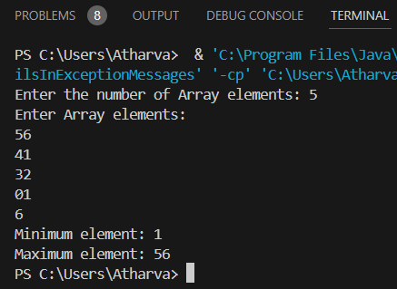

**1.Demonstrate how to find the Minimum and Maximum value in a given array.**

import java.util.Arrays;

import java.util.Scanner;

public class MinMaxInSortedArray1 {

public static void main(String[] args) {

Scanner obj = new Scanner(System.in);

System.out.print("Enter the number of Array elements: ");

int n = obj.nextInt();

int[] arr = new int[n];

System.out.println("Enter Array elements:");

for(int i=0; i<n; i++)

{

arr[i]=obj.nextInt();

}

Arrays.sort(arr);

int Minimum=arr[0];

int Maximum=arr[n - 1];

System.out.println("Minimum element: " +arr[0]);

System.out.println("Maximum element: " +arr[n - 1]);

}

}

**Output**

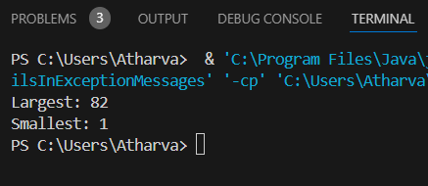

**2.Write a program to find the Smallest and Largest number using array.**

public class LargestExample {

public static void main(String[] args) {

int num[] = {55, 82, 43, 1, 12};

int smallest = num[0];

int largest = num[0];

for(int i = 1; i < num.length; i++) {

if(num[i] > largest) {

largest = num[i];

} else if(num[i] < smallest) {

smallest = num[i];

}

}

System.out.println("Largest: " + largest);

System.out.println("Smallest: " + smallest);

}

}

**Output**

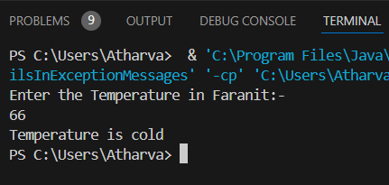

**3. Develop a program that checks the temperature input by the user and prints whether it is "Cold", "Warm", or "Hot".Define the temperature ranges for each category**

import java.util.*;

public class TempEx

{

public static void main(String args[])

{

Scanner obj = new Scanner(System.in);

System.out.println("Enter the Temperature in Faranit:-");

int Temperature=obj.nextInt();

if(Temperature<98f)

{

System.out.println("Temperature is cold");

}

else if(Temperature > 98f && Temperature < 150f)

{

System.out.println("Temperature Is Wram");

}

else

{

System.out.println("Temperature is Hot");

}

}

}

**Output**

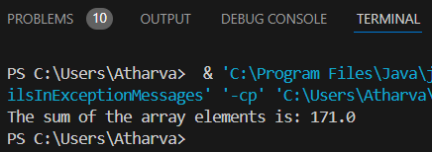

**4.Create array of 5 float element & Calculate their sum.**

public class FloatArraySum

{

public static void main(String[] args)

{

float[] numbers = {15.0f, 12.5f, 43.5f, 84.5f, 15.5f};

float sum = 0;

for (float number : numbers)

{

sum += number;

}

System.out.println("The sum of the array elements is: " + sum);

}

}

**Output**

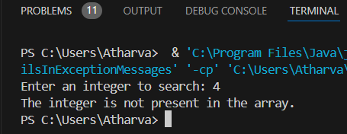

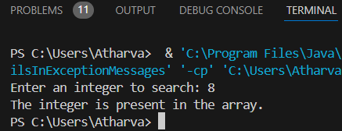

**5.Write a program to find out whether a given integer is present in an array or not.**

public class FindElementInArray

{

public static void main(String[] args)

{

int[] numbers = {3, 8, 15, 23, 42, 56, 78};

System.out.print("Enter an integer to search: ");

int target = Integer.parseInt(System.console().readLine());

boolean found = false;

for (int number : numbers)

{

if (number == target)

{

found = true;

break;

}

}

if (found)

{

System.out.println("The integer is present in the array.");

}

else

{

System.out.println("The integer is not present in the array.");

}

}

}

**Output**

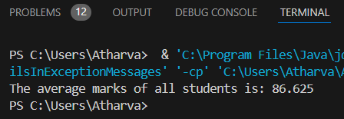

**6.Calculate the Avarage marks from an array containg marks of all Students in java using for loop.**

public class AvgMarks

{

public static void main(String[] args)

{

int[] marks = {85, 90, 78, 92, 88, 76, 95, 89};

int sum = 0;

for (int i = 0; i < marks.length; i++) {

sum += marks[i];

}

float average = (float) sum / marks.length;

System.out.println("The average marks of all students is: " + average);

}

}

**Output**

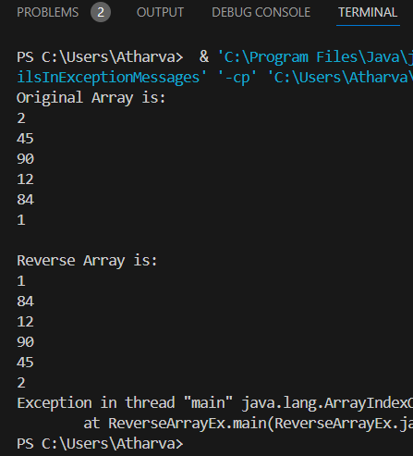

**7.Write a program to Reverse in array.**

import java.lang.reflect.Array;

public class ReverseArrayEx

{

public static void main(String args[])

{

int arr[] = new int[]{2,45,90,12,84,1};

System.out.println("Original Array is:");

for(int i = 0; i < arr.length; i++)

{

System.out.println(arr[i]);

}

System.out.println("\nReverse Array is:");

for(int i =5; i<=arr.length; i--)

{

System.out.println(arr[i]);

}

}

}